SHOULDER EXERCISES

PASSIVE RANGE OF MOTION (ROM) - Restoring range of motion is a primary goal of rehabilitation.

Pendulum Swings  Bend over at the waist, rest supporting arm on a table and place your head on your arm. The injured shoulder should be relaxed and freely hanging downward. Gently swing your arm in a circular pattern, clockwise and counter-clockwise. | Hang arm for 30 sec  Swing for 60 sec  Repeat 3-6 times/day | 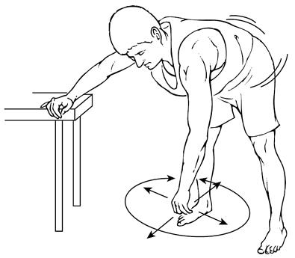
External Rotation  Lying on your back with a small towel roll under your injured arm. Grasp the ends of a stick with both hands. Keeping your elbows at a 90º angle at your side. Using your strong arm push your surgical arm away from your body. | Hold for 5-10 sec  Repeat 10 times  Try to do 3 sets/day | 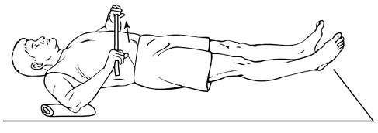
Passive Extension (Phase 1)  Using your non-operative arm place your operative hand on a table top. Place your non-operative hand on the elbow of the operative arm and push it forward. Then sit down or bend at the waist to increase the stretch. Progress to phase 2 when this is comfortable. | Hold for 5-10 sec  Repeat 10 times  Do 3 sets/day | 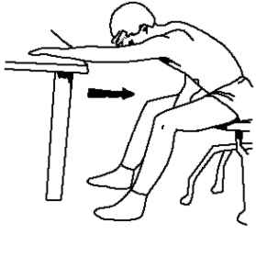
Passive Extension (Phase 2)  Lying on your back. Hold the stick length wise towards your head with your injured arm on the top and your other arm in the middle of the stick. Slowly raise your injured arm upward over your head, making sure to keep your injured arm relaxed. | Hold for 5-10 sec  Repeat 10 times  Try to do 3 sets/day | 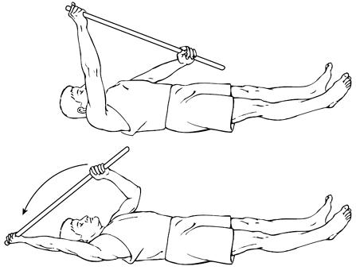
Internal Rotation  Stand with your strong arm above your head holding a towel (or stick). Grasp the towel down towards your hips with your injured arm. Keeping your injured arm relaxed as you slowly raise the hand above your head until you feel as stretch. | Hold for 5-10 sec  Repeat 10 times  Try to do 3 sets/day | 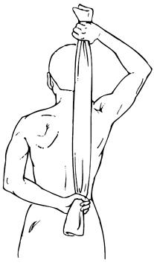
Internal Rotation (Phase 2)  Lie on your affected side with your shoulder tucked under your body and elbow at a 90 degree angle from your body. Slightly roll your body over towards your shoulder. With the top arm, rress fist of the bottom shoulder downward towards the table (away from your head). | Hold for 5-10 sec  Repeat 10 times  Try to do 3 sets/day | 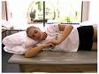

SHOULDER STRENGTHENING EXERCISES

EXERCISES- Exercises should be performed only once a day to start. You should increase your sets every 3-5 days as long as you do not have an increase in pain. Your goal: 3 sets of 10 to 15 repetitions daily.

External Rotation  Place a towel roll under your armpit. Put one end of the tubing in the door (at elbow height) and the other side in your hand. Keep elbow at your side bent to 90º with your thumb up. The hand should be moved outward, 45° away from the body. | Hold for 5-10 sec  Repeat 10-15 times | 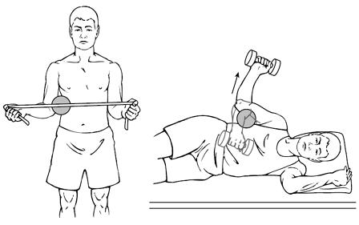
Internal Rotation  Place a towel roll under your armpit. Put one end of the tubing in the door (at elbow height) and the other side in your hand. Keep your elbow at your side bent to 90º arm rotated outward approx. 45º from your hip with your thumb up. The hand should move inward, until perpendicular with hip. | Hold for 5-15 sec  Repeat 10-15 times | 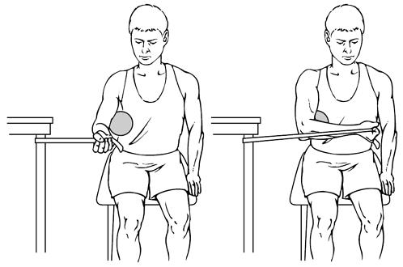
Shoulder Abduction  No towel roll. Place one end of the tubing in the door at shin height. Hold the tubing in your hand with thumb upward. Lift arm upward at a 45º from your hip with your arm straight. Hold, slowly lower to start position. | Hold for 5-15 sec  Repeat 10-15 times | 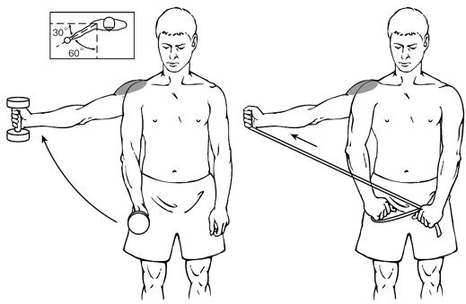
Chest Press  Set 1: No tubing. Shrug shoulders upward then extend arms in front of you, reaching with your fingertips and relaxing your shoulders downward. This should create a nice stretch between your shoulder blades.  Set 2&3: Put tubing knot in door jam at head height. Stand with back to wall, legs hip distance apart and arms at shoulder level. Shrug your shoulders upward then push your arms straight downward in front of your body. While keeping your arms extended, push your shoulder blades off the wall and control them back to the wall. | Hold for 5 sec  Repeat 10 times  1 Set  Hold 5 seconds  Repeat 10-15 times  2 sets per day | 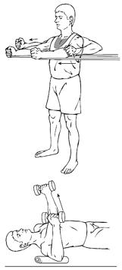
Row  Set 1: No tubing. Shrug shoulders upward then roll them back and squeeze your shoulder blades together (pretend you are holding a pencil).  Set 2: Put tubing in door jam either at head height or at chest height. Stand with legs hip distance apart and staggered, facing the door. Start with arms straight out in front. Pull arms hips. Focus on squeezing your shoulder blades together. | Hold for 5-10 sec  Repeat 10-15 times  1 Set  Hold for 5 sec  Repeat 10-15 times  3 sets per day | 